Pennsylvania Green Energy Loan Fund
Procedures Manual for the Six GELF Affidavits

Table of Contents

1. Disadvantaged Businesses - Equal Opportunity 1
Attachment 1: GELF Disadvantaged Business Affidavit 4
2. Davis-Bacon Act and Prevailing Wages 6
Attachment 2: GELF Davis-Bacon Act Affidavit 9
3. National Environmental Policy Act (NEPA) 11
Attachment 3: GELF NEPA Affidavit 14
4. Historical Preservation Provisions 17
Attachment 4: GELF Historic Preservation Affidavit 20
5. Project Waste Management Plan 23
Attachment 5: GELF Waste Management Plan Affidavit 25
6. Buy American Provisions 28
Attachment 6: GELF Buy American Affidavit 31

1. Disadvantaged Businesses - Equal Opportunity
A. Background
The Pennsylvania Green Energy Loan Fund (“GELF”) must ensure that all GELF energy loan recipients are in compliance with the certain equal opportunity provisions as mandated by the federal American Recovery and Reinvestment Act (“ARRA”) and Commonwealth law. These regulatory requirements flow from the U.S. Department of Energy (“USDOE”) to the Pennsylvania Department of Environmental Protection (“PADEP”) to Reinvestment Fund to all GELF loan recipients.
GELF loan recipients are required to comply with all applicable federal Disadvantaged Business Enterprise (DBE) requirements. Borrowers must also comply with the Commonwealth’s small disadvantaged business policies as well as with the Governor’s Executive Order 2009-02: Creating Opportunities for Small and Disadvantaged Businesses in the Expenditure of Federal Stimulus Monies (see http://www.pabulletin.com/ secure/data/vol39/ 39-48/39_48_gv.pdf). This order established the goal that 10% of all ARRA-supported contracts involve small disadvantaged businesses, which include Minority Business Enterprises (MBEs), Women Business Enterprises (WBEs) and Veteran Owned Business Enterprise (VOBEs).
All GELF Loan Recipients will make reasonable and good faith efforts to meet and or exceed the Governor’s goal of providing maximum practicable opportunities for small disadvantaged businesses to participate as contractors, professional service providers, subcontractors, and suppliers. As a condition to receiving a GELF energy loan, all GELF loan recipients must prepare and submit a GELF Disadvantaged Businesses Affidavit certifying that they and their project is in compliance with the equal opportunity provisions. This affidavit is described in section 1.B.6 below and a copy of the affidavit is included in Attachment 1 of this GELF Procedures Manual.
B. GELF Loan Recipient Actions
- GELF loan recipients will make reasonable and good faith efforts to provide maximum practicable opportunities for small disadvantaged businesses to participate as contractors, professional service providers, subcontractors, and suppliers. Early discussion with GELF staff about the disadvantaged business requirements and the affidavit are strongly encouraged. Any questions should be directed to Roger Clark at roger.clark@reinvestment.com or by phone to 215.574.5814.
- GELF Loan Recipients will consult with the Pennsylvania Department of General Services’ Bureau of Minority and Women Business Opportunities to ensure that certified Minority Business Enterprises (MBEs), Women Business Enterprises (WBEs) and Veteran Owned Business Enterprise (VOBEs) participate in GELF-supported projects. GELF Loan Recipients are required to make best efforts to ensure MBEs, WBEs and VOBEs participate in all phases of a GELF project, from the engineering and design services to the suppliers of equipment, products and commodities used in the projects to the contractors who install the energy measures and implement the project.
The contact information for this office is:
Bureau of Minority and Women Business Opportunities
North Office Building - Room 611
401 North Street
Harrisburg, PA 17120-0500
Harrisburg office phone: 717.783.3119
Pittsburgh office phone: 412.442.5872
Philadelphia office phone: 215.965.1105
web: http://www.portal.state.pa.us/portal/server.pt/community/ bureau_of_minority_and_ women_business_opportunities/1358
email: gs-bmwbo@state.pa.us
- GELF Loan Recipients will participate in outreach activities and events to increase small disadvantaged business interest and participation in GELF projects. Guidance about these opportunities will be provided by the Bureau of Minority and Women Business Opportunities.
- GELF Loan Recipients will include MBEs, WBEs and VOBEs on all solicitation lists for services, equipment, products and commodities they seek through competitive bids for the project.
The Bureau of Minority and Women Business Opportunities maintains a searchable database of MBEs and WBEs that can be accessed by classification code for the service or products. The database is can be accessed at http://www.dgsweb.state.pa.us/mbewbe/VendorSearch.aspx.
The Bureau stands ready to assist any GELF Loan Recipient. GELF Loan Recipients are invited to call the Bureau, explain your project and your needs and they will provide assistance.
- The GELF Loan Recipient will prepare and keep records of all solicitations for GELF projects, including a bid tabulation showing names of all firms solicited and the dollar amount of the bid, quote or proposal, as well as copies of all bids, quotes and proposals received.
The GELF Loan Recipient shall complete and submit a GELF Disadvantaged Businesses Affidavit that is provided as Attachment 1 of this Procedures Manual. This affidavit is a condition of loan closing and must be submitted prior to the GELF loan closing date. The copy of GELF Disadvantaged Businesses Affidavit is provided as Attachment 1 for reference only. GELF staff will provide GELF loan applicants with the electronic version of the affidavit, which is a Microsoft Word form that has fields that expand to the needed size for each answer. GELF loan applicants should fill out the Microsoft Word version of the affidavit.
The completed affidavit in hard copy with an original signature is to be submitted to:
Roger Clark
PA Green Energy Loan Fund
Reinvestment Fund
1700 Market Street - 19th Floor
Philadelphia, PA 19103.
In addition to the hard copy, an electronic version of the completed affidavit is to be emailed to:
roger.clark@reinvestment.com
- Every GELF Loan Recipient will submit an updated GELF Disadvantaged Businesses Affidavit as necessary to capture any changes to the status of compliance with the disadvantaged businesses provisions and the project’s contractors.
- Throughout the construction phase of the project, the GELF Loan Recipient will provide monthly reports to Reinvestment Fund on MBE and WBE utilization. These monthly reports will include a list of all MBEs and WBEs who receive contracts to provide services, equipment, products or commodities for a GELF project. The list will include a brief description of the services, equipment, products or commodities being provided and the dollar value of the contract.
C. Reinvestment Fund Actions
- Reinvestment Fund will provide a copy of this Economic Opportunity procedure document to each GELF loan applicant and will respond to any questions that the applicants have.
- Reinvestment Fund will distribute the GELF Disadvantaged Businesses Affidavit to all GELF loan applicants and will work all GELF Loan Recipients to ensure the affidavit is completed and submitted to Reinvestment Fund prior to loan closing. The affidavits will be available to PADEP staff for inspection.
- Reinvestment Fund will contact the Pennsylvania Department of General Services’ Bureau of Minority and Women Business Opportunities on a regular basis to determine if the Bureau has any recommendations for increasing the opportunities for small disadvantaged businesses to participate in GELF.
- Reinvestment fund will review the monthly reports provided by the GELF Loan Recipient to the Bureau of Minority and Women Business Opportunities on MBE and WBE utilization. The monthly reports will be filed in the GELF Loan Recipient’s project file.
- Reinvestment Fund will provide a report to PADEP, on a format provided by PADEP to report participation of Minority and Women Business Opportunities on MBE and WBE utilization. This report will be updated and sent to PADEP as new information is acquired.

Attachment 1: GELF Small Diverse Business Participation Affidavit

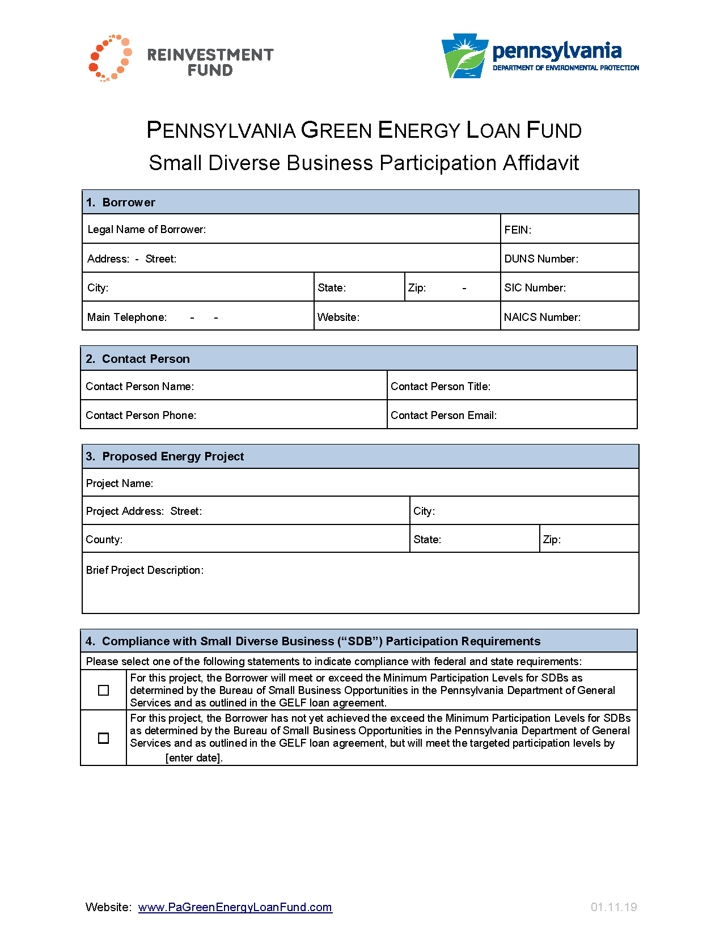
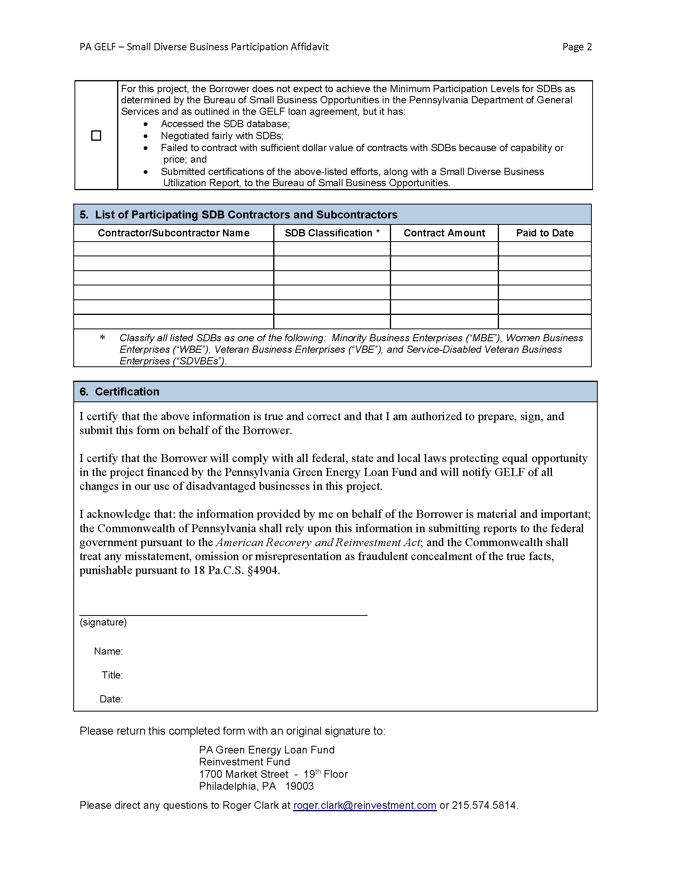

2. Davis-Bacon Act and Prevailing Wages
A. Background
The Pennsylvania Green Energy Loan Fund (“GELF”) must ensure that all GELF energy loan recipients are in compliance with the prevailing wage provisions of the Davis-Bacon Act, 40 U.S.C. §§3141 et seq., as mandated by the American Recovery and Reinvestment Act (“ARRA”). Section 1606 of ARRA requires that all laborers and mechanics employed by contractors and subcontractors on projects involving construction, alteration, and/or repair valued in excess of $2,000 funded directly by or assisted in whole or in part by and through the Federal Government pursuant to ARRA shall be paid wages at rates not less than those prevailing on projects of a character similar in the locality as determined by the U.S. Secretary of Labor in accordance with subchapter IV of chapter 31 of title 40, United States Code.
These regulatory requirements flow from the U.S. Department of Energy (“USDOE”) to the Pennsylvania Department of Environmental Protection (“PADEP”) to Reinvestment Fund to all GELF loan recipients. As a condition to receiving a GELF energy loan, all GELF loan recipients must prepare and submit a GELF Davis-Bacon Act Affidavit certifying that they and their project is in compliance with the prevailing wage provisions of the Davis-Bacon Act. This affidavit is described in section 2.B.2 below and a copy of the affidavit is included in Attachment 2 of this GELF Procedures Manual.
DOE has issued Guidance on Implementation of the Davis-Bacon Act Prevailing Wage Requirements for State Energy Program Grant Recipients Under the American Recovery and Reinvestment Act of 2009 on April 7, 2010. This document, State Energy Program Notice 10-003, is available at http://www1.eere.energy.gov/ wip/pdfs/sep_dba_program_notice_10-003A.pdf.
GELF will advise GELF Loan Recipients about the process for timely submission of the weekly certified payroll forms. A copy of a certified payroll form (WH-347) can be found at www.dol.gov/whd/recovery/index.htm.
B. GELF Loan Recipient Actions
- The GELF Loan Recipient shall review the Davis-Bacon Act Desk Guide prepared by the USDOE and available for download at www1.eere.energy.gov/wip/pdfs/ doe_dba_desk_guide_061610.pdf and make certain that it and all of its contractors and subcontractors on the project are familiar with the prevailing wage provisions of the Davis-Bacon Act.
The GELF Loan Recipient shall complete and submit a GELF Davis-Bacon Act Affidavit that is provided as Attachment 2 of this Procedures Manual. This affidavit is a condition of loan closing and must be submitted prior to the GELF loan closing date. The copy of GELF Davis-Bacon Act Affidavit is provided as Attachment 2 for reference only. GELF staff will provide GELF loan applicants with the electronic version of the affidavit, which is a Microsoft Word form that has fields that expand to the needed size for each answer. GELF loan applicants should fill out the Microsoft Word version of the affidavit.
Early discussion with GELF staff about this affidavit and the prevailing wage requirements are strongly encouraged. Any questions should be directed to Roger Clark at roger.clark@reinvestment.com or by phone to 215.574.5814.
The completed affidavit with an original signature is to be submitted to:
Roger Clark
PA Green Energy Loan Fund
Reinvestment Fund
1700 Market Street - 19th Floor
Philadelphia, PA 19103.
In addition to the hard copy, an electronic version of the completed affidavit is to be emailed to:
roger.clark@reinvestment.com
- Every GELF Loan Recipient will submit an updated GELF Davis-Bacon Act Affidavit as necessary to capture any changes to the status of compliance with the Davis-Bacon Act provisions.
- Every GELF Loan Recipient will obtain wage determinations from the website of the U.S. Department of Labor at http://www.wdol.gov/ for all work positions at its GELF project. The GELF Loan Recipient will provide a copy of all relevant wage determinations to Reinvesment Fund. Wage determinations shall be provided to Reinvestment Fund prior to the payment of Davis-Bacon Act wages.
- Every GELF Loan Recipient will submit a weekly certified payroll to Reinvestment Fund. The weekly certified payroll form (WH-347) is available at http://www.dol.gov/whd/forms/wh347.pdf.
- Every GELF Loan Recipient will agree to open its work sites to unscheduled inspections by staff from the USDOE and PADEP including but not limited to interviews with workers and management staff, audits of payrolls or other records consistent with the inspectors’ mandate to ensure compliance with the requirements of the Davis-Bacon Act.
C. Reinvestment Fund Actions
- Reinvestment Fund will provide a copy of this Davis-Bacon Act procedure document to each GELF loan applicant and will respond to any questions that the applicants have.
- Reinvestment Fund will distribute the GELF Davis-Bacon Act Affidavit to all GELF loan applicants and will work with all GELF Loan Recipients to ensure the affidavit is completed and submitted to Reinvestment Fund prior to loan closing. The affidavits will be available to PADEP staff for inspection.
- Reinvestment Fund will receive the wage determination reports submitted by the GELF Loan Recipients and include it in the project file. Reinvestment Fund will contact the GELF Loan Recipients who fail obtain or submit these wage determination reports to Reinvestment Fund.
- Reinvestment Fund will collect the weekly certified payrolls submitted by the GELF Loan Recipients. Reinvestment Fund will contact the GELF Loan Recipients who fail to submit the certified payrolls on a timely basis. Reinvestment Fund will review these for compliance and transmit the weekly certified payroll forms it receives from the GELF Loan Recipients to PADEP’s program officer for the GELF Loan Program.

Attachment 2: GELF Davis-Bacon Act Affidavit

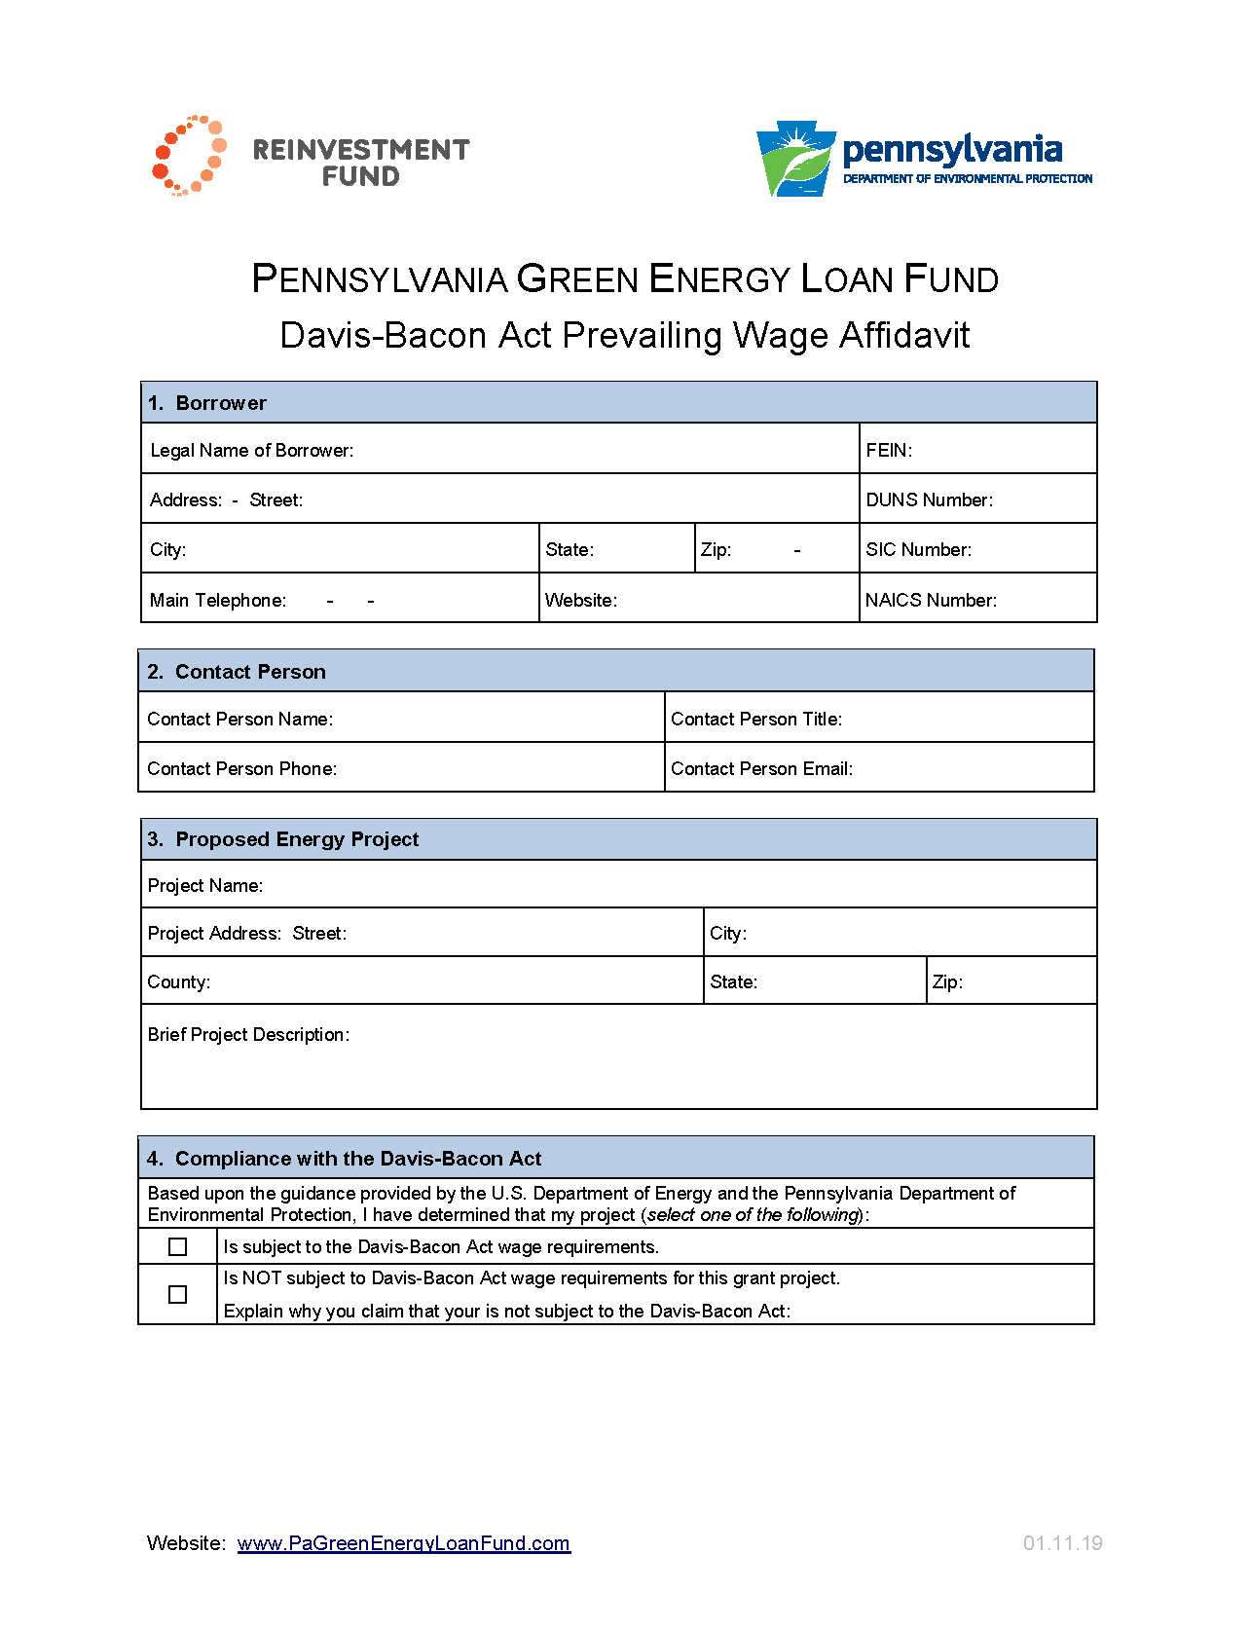
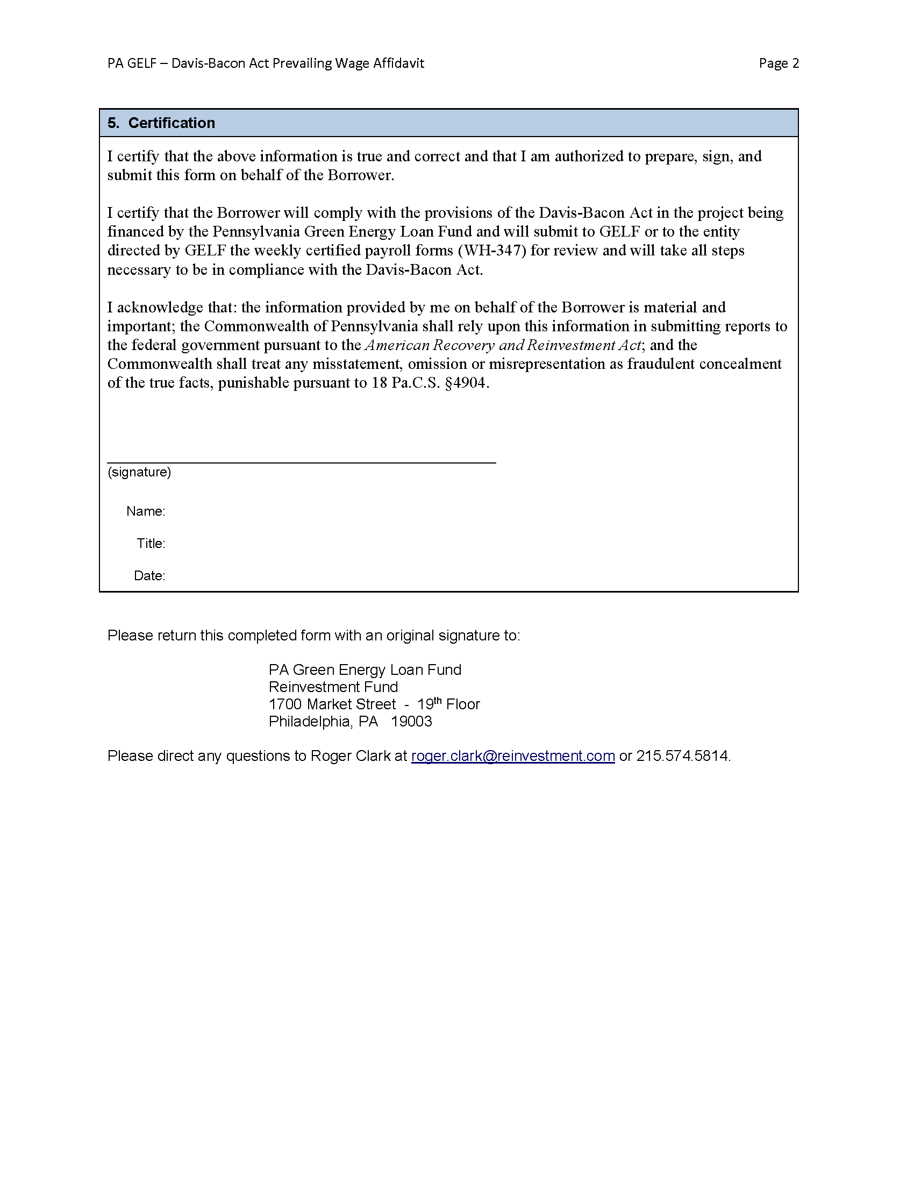

3. National Environmental Policy Act (NEPA)
A. Background
Recipients of GELF energy loans will comply with all applicable Federal, State, and local environmental requirements, including: National Environmental Policy Act (“NEPA”), National Historic Preservation Act, Endangered Species Act, the Clean Air Act, the Federal Water Pollution and Control Act, and Executive Orders on Floodplains (11988), Wetlands (11990) and Environmental Justice (12898). These regulatory requirements flow from the U.S. Department of Energy (“USDOE”) to the Pennsylvania Department of Environmental Protection (“PADEP”) to Reinvestment Fund to all GELF loan recipients. As a condition to receiving a GELF energy loan, all GELF loan recipients must prepare and submit a GELF NEPA Affidavit certifying that they and their project is in compliance with environmental law. This affidavit is described in section 3.B.2 below and a copy of the affidavit is included in Attachment 3 of this GELF Procedures Manual.
Formal guidance on environmental compliance issues was issued by DOE on December 17, 2009. This guidance, SEP Program Notice 10-001, is available at http://www1.eere.energy.gov/wip/pdfs/ nepa_program_guidance_notice_10-003.pdf. Additional NEPA guidance is available at the main DOE web page NEPA at http://www1.eere.energy.gov/wip/nepa_guidance.html.
DOE has concluded that many types (or classes) of actions normally do not have the potential to cause significant environmental impacts and, thus, are categorically excluded from the need for additional NEPA review. The list of DOE’s Categorical Exclusions is contained in Appendices A and B to Subpart D of DOE’s NEPA regulations (10 CFR Part 1021), which can be found at http://www1.eere.energy.gov/wip/pdfs/template_nepa_review.pdf.
GELF will give strong preference to projects that meet DOE guidelines for Categorical Exclusions (or CX) from NEPA environmental review. If a project does not fully qualify for the Categorical Exclusion, the GELF loan recipient will assist Reinvestment Fund and PADEP in completing an ES-1 form to obtain approval from DOE. The ES-1 form template will be provided if needed. All ES-1 forms will be submitted to DOE by the DEP GELF program officer.
B. GELF Applicant Actions
- All GELF applicants will carefully review the DOE guidance document on NEPA, available at http://www1.eere.energy.gov/wip/pdfs/nepa_program_guidance_notice_10-003.pdf, with special attention to the specific energy measures that are Categorically Excluded from NEPA review.
- The GELF Loan Recipient shall complete and submit a GELF NEPA Affidavit that is provided as Attachment 3 of this Procedures Manual. This affidavit is a condition of loan closing and must be submitted prior to the GELF loan closing date. The copy of GELF NEPA Affidavit is provided as Attachment 3 for reference only. GELF staff will provide GELF loan applicants with the electronic version of the affidavit, which is a Microsoft Word form that has fields that expand to the needed size for each answer. GELF loan applicants should fill out the Microsoft Word version of the affidavit.
Early discussion with GELF staff about this affidavit and the NEPA requirements are strongly encouraged. Any questions should be directed to Roger Clark at roger.clark@reinvestment.com or by phone to 215.574.5814.
The completed affidavit with an original signature is to be submitted to:
Roger Clark
PA Green Energy Loan Fund
Reinvestment Fund
1700 Market Street - 19th Floor
Philadelphia, PA 19103.
In addition to the hard copy, an electronic version of the completed affidavit is to be emailed to:
roger.clark@reinvestment.com
- In the GELF NEPA Affidavit, all GELF applicants will inform Reinvestment Fund of all proposed measures in their project that fall with the Categorical Exclusions and all proposed energy measures that fall outside the Categorical Exclusions. The strong preference is for GELF to fund energy measures that qualify for the Categorical Exclusion.
- If the GELF applicant and Reinvestment Fund agree that there are energy measures of merit that fall outside the Categorical Exclusions, then the GELF applicant will complete the first draft of the ES-1 form, which will be provided as needed. The GELF applicant will submit to Reinvestment Fund an electronic version of the draft ES-1 form for review and editing. The GELF applicant will comply with the final DOE ruling on the ES-1 request and make appropriate modifications to the GELF financing request.
- Every GELF Loan Recipient will submit an updated GELF NEPA Affidavit as necessary to capture any changes to the measures being implemented with GELF financing or the status of compliance with NEPA provisions.
- Throughout the GELF project, the GELF Loan Recipient will comply with all local, state and federal environmental regulations and requirements and will secure all necessary permits.
C. Reinvestment Fund Actions
- Reinvestment Fund will provide a copy of this NEPA procedure document to each GELF loan applicant and will respond to any questions that the applicants have.
- Reinvestment Fund will distribute the GELF NEPA Affidavit to all GELF loan applicants and will work all GELF Loan Recipients to ensure the affidavit is completed and submitted to Reinvestment Fund prior to loan closing. The affidavits will be available to PADEP staff for inspection.
- Reinvestment Fund will review the list of proposed energy measures submitted by the GELF applicant and will determine whether the GELF applicant has correctly classified the proposed measures into those that qualify for Categorical Exclusion and those that do not. Reinvestment Fund will consult with the DEP GELF program officer on any issues or questions.
- If an ES-1 form is necessary, Reinvestment Fund will review the GELF applicant’s first draft of the ES-1 form and propose any appropriate changes. Once Reinvestment Fund and the GELF applicant are in agreement with the draft ES-1, Reinvestment Fund will forward the document to the DEP GELF program officer for review and edits of the ES-1 form. The DEP GELF program officer will file the ES-1 form with DOE for review and approval.
- Reinvestment Fund will communicate the DOE final action to the GELF applicant. Reinvestment Fund will work with the GELF applicant to bring the project’s energy measures into compliance with the DOE determination on the ES-1 request.

Attachment 3: GELF NEPA Affidavit

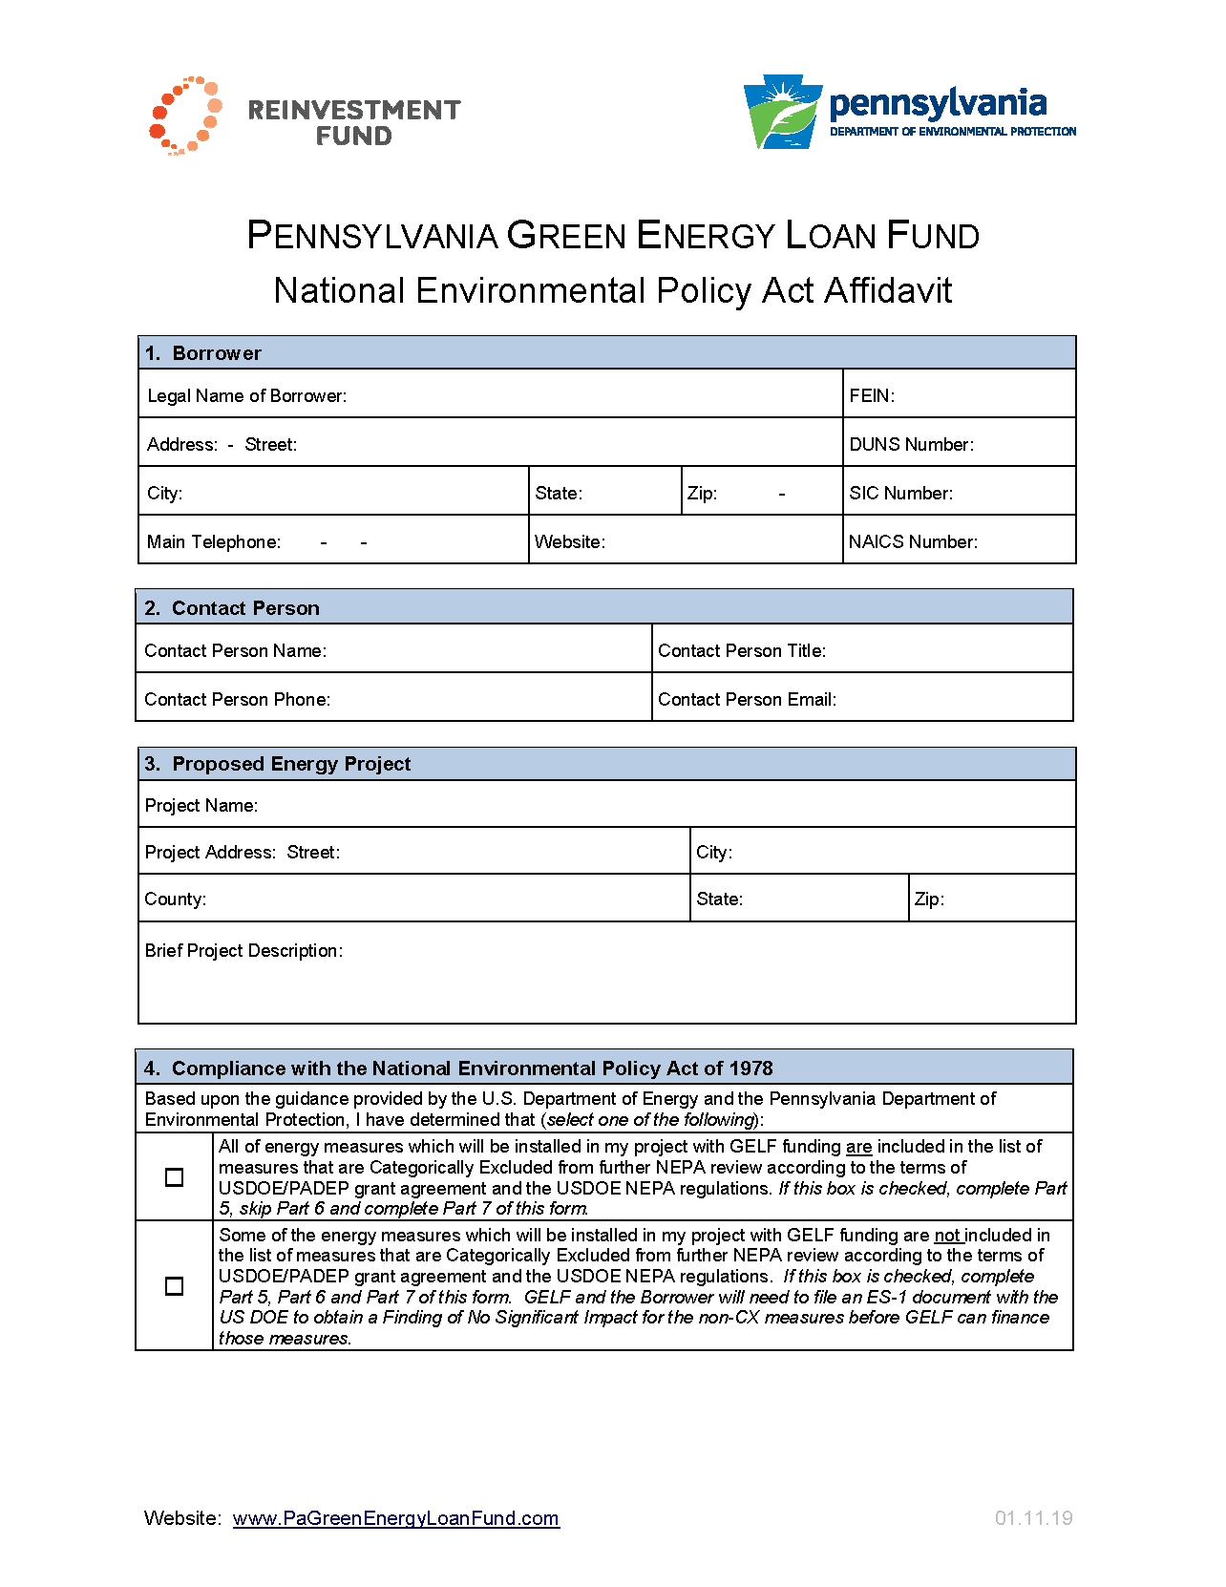
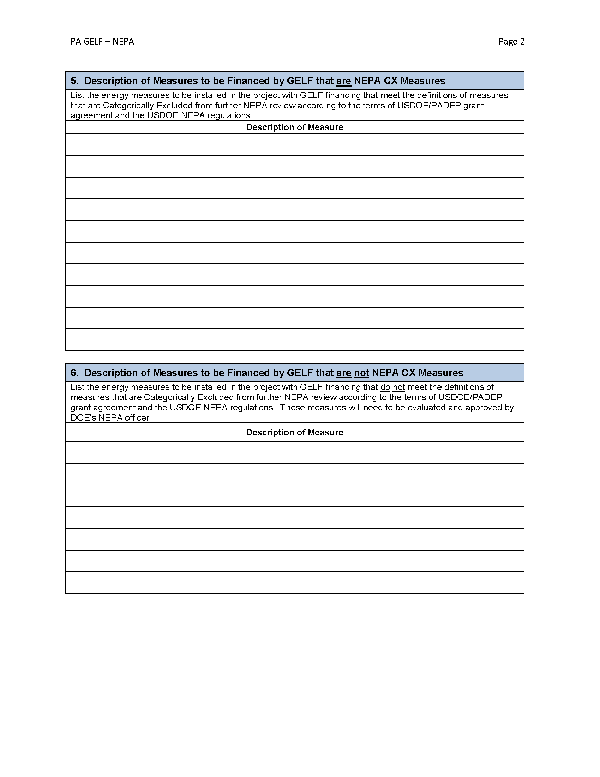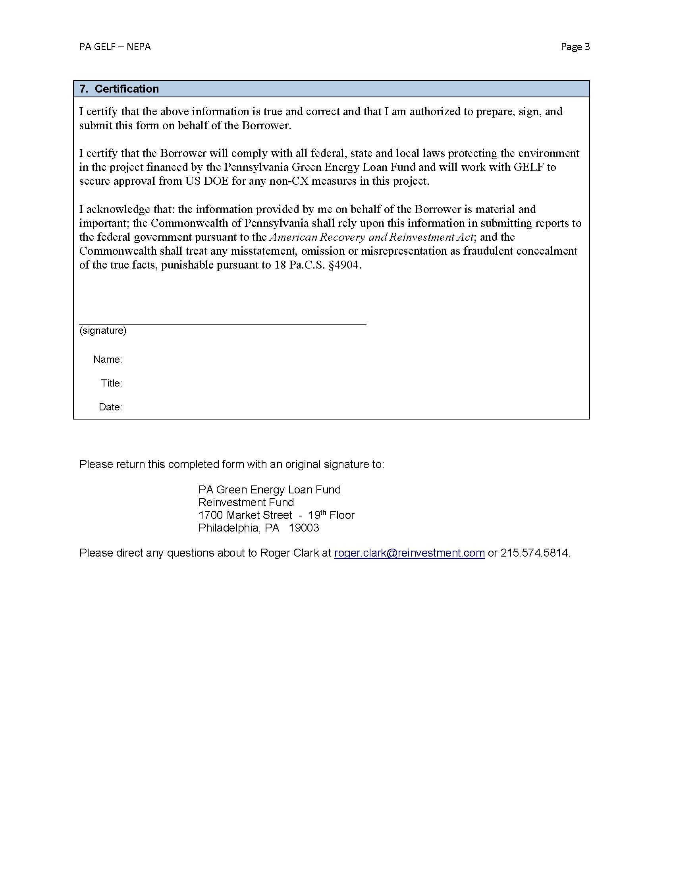

4. Historical Preservation Provisions
A. Background
The Pennsylvania Green Energy Loan Fund (“GELF”) must ensure that all GELF energy loan recipients are in compliance with the historic preservation provisions as mandated by the federal National Historic Preservation Act of 1966. These regulatory requirements flow from the U.S. Department of Energy (“USDOE”) to the Pennsylvania Department of Environmental Protection (“PADEP”) to Reinvestment Fund to all GELF loan recipients. As a condition to receiving a GELF energy loan, all GELF loan recipients must prepare and submit a GELF Historic Preservation Affidavit certifying that they and their project is in compliance with environmental law. This affidavit is described in section 4.B.1 below and a copy of the affidavit is included in Attachment 4 of this GELF Procedures Manual.
Historic preservation issues arise in projects that involve buildings that are:
  - 50 or more years old;
  - located in a building on the National Register of Historic Places (see http://www.nps.gov/nr/); or,
  - located in a local historic district on the National Register of Historic Places (see http://www.nps.gov/nr/).
If none of these apply to a project, then no additional work is necessary on the issue of historic preservation. If the building involved meets one of more of these criteria, then additional work to comply with the historic preservation requirements is needed.
The U.S. Department of Energy (DOE) has created a web page that addresses the Section 106 review under the NHPA and other historic preservation issues that can be found at http://eere.energy.gov/wip/historic_ preservation.html. GELF is subject to the DOE guidance on the historic preservation issued as SEP Program Notice 10-006 on February 11, 2010 and available at http://eere.energy.gov/wip/pdfs/ historic_preservation_program_ guidance.pdf. The federal regulation implementing the Section 106 review process appear in the U.S. Code of Federal Regulations at 36 CFR Part 800 (see http://www.achp.gov/regs-rev04.pdf).
DOE has executed a Programmatic Agreement with PADEP and the Pennsylvania Historical and Museum Commission (“PHMC”) that lists the many energy measures that do not have the potential to negatively affect historic properties and makes those measure exempt from further Section 106 review. The Programmatic Agreement can be found at http://www1.eere.energy.gov/wip/pdfs/ historic_preservation_doe_prototype_pa.pdf. Appendix A and Appendix B contain the list of energy measures that are exempt for purposes of GELF.
If the historic preservation rules apply to a project, the next issue is whether GELF is financing only energy measures that are on the exempt measure list in Appendix A and Appendix B of the Programmatic Agreement ( http://www1.eere.energy.gov/wip/pdfs/historic_preservation_doe_ prototype_pa.pdf). If so, then no formal review is needed by the PHMC.
For projects implementing measures not exempt under the Programmatic Agreement, GELF and the GELF applicant will need to work with PHMC to determine what level of Section 106 review is needed. The PHMC website is http://www.portal.state.pa.us/portal/server.pt/community/ phmc_home/1426. Information about the Bureau and its Section 106 review process is available at http://www.portal.state.pa.us/portal/server.pt/community/historic_preservation/3741.
The contact person at the Bureau for Historic Preservation is Ann Safley. Her contact information is:
Ann Safley
Bureau for Historic Preservation
Pennsylvania Historical and Museum Commission
Commonwealth Keystone Building - 2nd Floor
400 North Street
Harrisburg, PA 17120-0093
phone: 717.787.9121
email: rsafley@state.pa.us
B. GELF Applicant Actions
- The GELF Loan Recipient shall complete and submit a GELF Historic Preservation Affidavit that is provided as Attachment 3 of this Procedures Manual. This affidavit is a condition of loan closing and must be submitted prior to the GELF loan closing date. The copy of GELF Historic Preservation Affidavit is provided as Attachment 3 for reference only. GELF staff will provide GELF loan applicants with the electronic version of the affidavit, which is a Microsoft Word form that has fields that expand to the needed size for each answer. GELF loan applicants should fill out the Microsoft Word version of the affidavit.
Early discussion with GELF staff about this affidavit and the historic preservation requirements are strongly encouraged. Any questions should be directed to Roger Clark at roger.clark@reinvestment.com or by phone to 215.574.5814.
The completed affidavit with an original signature is to be submitted to:
Roger Clark
PA Green Energy Loan Fund
Reinvestment Fund
1700 Market Street - 19th Floor
Philadelphia, PA 19103.
In addition to the hard copy, an electronic version of the completed affidavit is to be emailed to:
roger.clark@reinvestment.com
- If the proposed project involves a building subject to the historical preservation requirements and will have energy measures not exempt as listed in Appendix A and Appendix B of the Programmatic Agreement, the GELF applicant will pursue further historic preservation review of the project. The GELF applicant will, at the earliest feasible time, file a Request to Initiate Consultation in Compliance with the State History Code and Section 106 of the National Historic Preservation Act with the Bureau for Historic Preservation of the Pennsylvania Historical and Museum Commission. The Request to Initiate Consultation form is available at: http://www.portal.state.pa.us/portal/server.pt/gateway/PTARGS_0_77423_29938_3741_418107_43/http;/pubcontent.state.pa.us/publishedcontent/publish/cop_environment/phmc/communities/extranet/preservationprograms/redolayout/section106pahistorycoderlinks/links/ER_submission_form.doc. The GELF Loan Recipients will inform the Bureau that they will be receiving financial assistance from the American Recovery and Reinvestment Act through the U.S Department of Energy and the Pennsylvania Department of Environmental Protection.
- The GELF applicant will cooperate with the Bureau for Historic Preservation and submit in a timely manner all information requested by the Bureau in its Section 106 review.
- The GELF applicant will provide Reinvestment Fund with a copy of all documents and materials it submits to the Bureau or that it receives from the Bureau.
- Every GELF Loan Recipient will submit an updated GELF Historic Preservation Affidavit as necessary to capture any changes to the measures being implemented with GELF financing or the status of compliance with the historic preservation provisions.
C. Reinvestment Fund Actions
- Reinvestment Fund will provide a copy of this historical preservation procedure document to each GELF loan applicant and will respond to any questions that the applicants have.
- Reinvestment Fund will distribute the GELF Historic Preservation Affidavit to all GELF loan applicants and will work all GELF Loan Recipients to ensure the affidavit is completed and submitted to Reinvestment Fund prior to loan closing. The affidavits will be available to PADEP staff for inspection.
- If the Historic Preservation provisions do not apply, no further action is necessary.
- For those projects that are subject to the historical preservation requirements and that are seeking to finance energy measures not in Appendix A and Appendix B of the Programmatic Agreement, Reinvestment Fund will monitor the Applicant’s interaction with the Pennsylvania Historic and Museum Commission. Reinvestment Fund will receive a copy of the Request for Consultation form submitted by the GELF applicant. The Request for Consultation form will be filed in the GELF Loan Recipient’s project file.
- Reinvestment Fund will receive all other documents relevant to the Section 106 review submitted by the GELF applicant or the Bureau of Historic Preservation. All documents will be filed in the GELF Loan Recipient’s project file. All Documents will be provided to PADEP’s Program Officer for review and approval.

Attachment 4: GELF Historic Preservation Affidavit

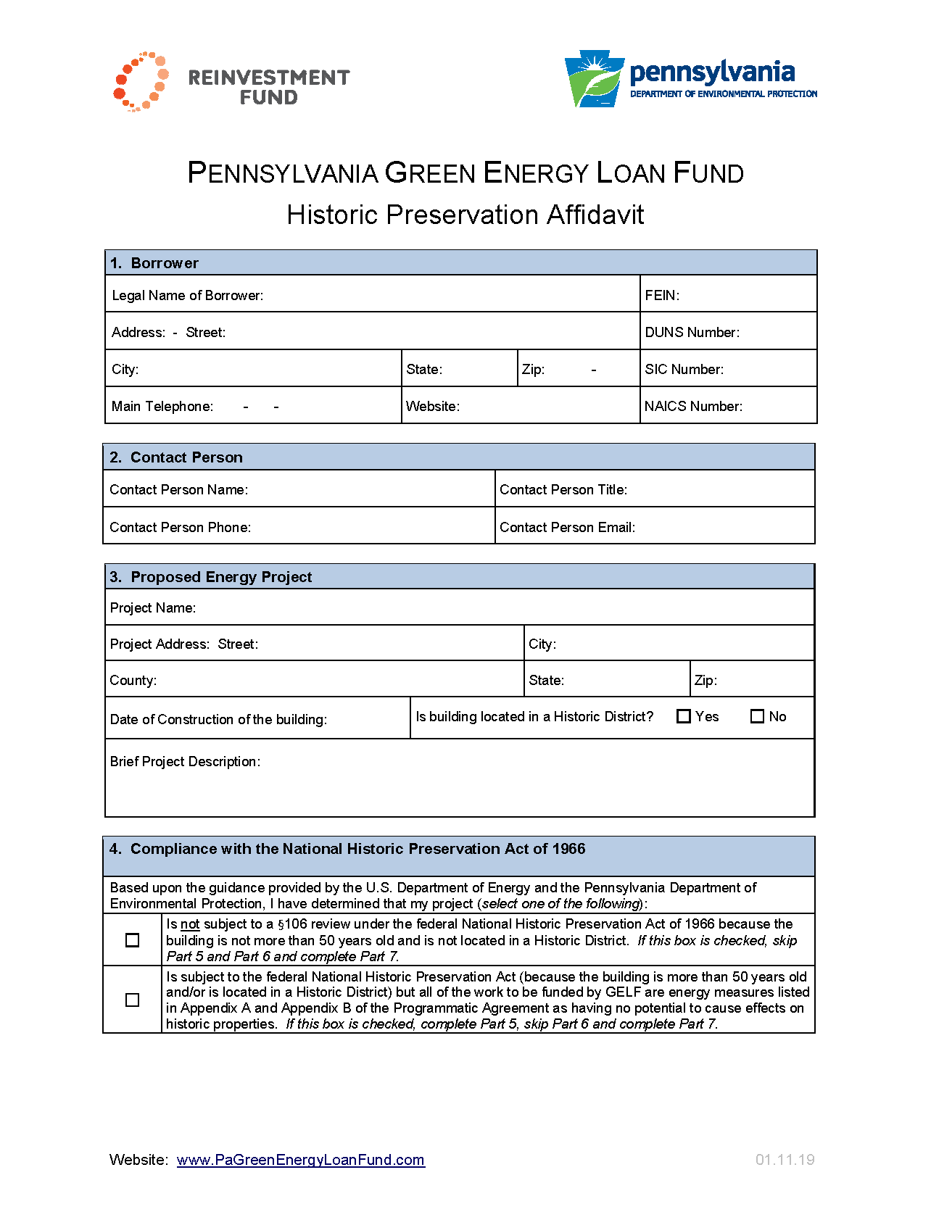
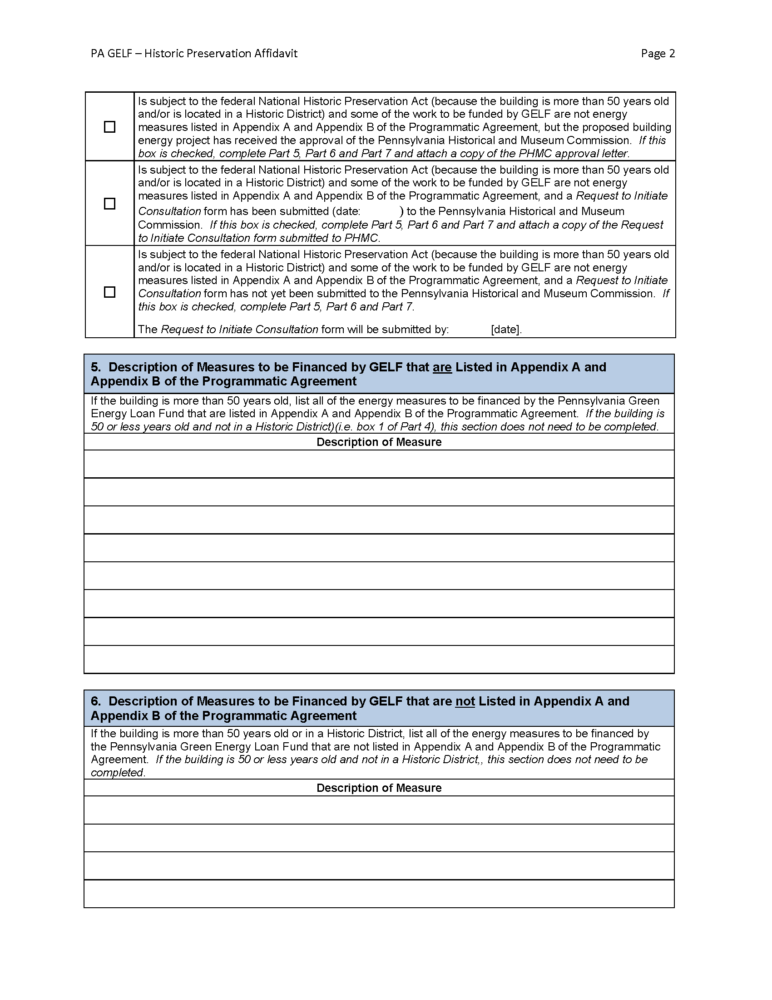

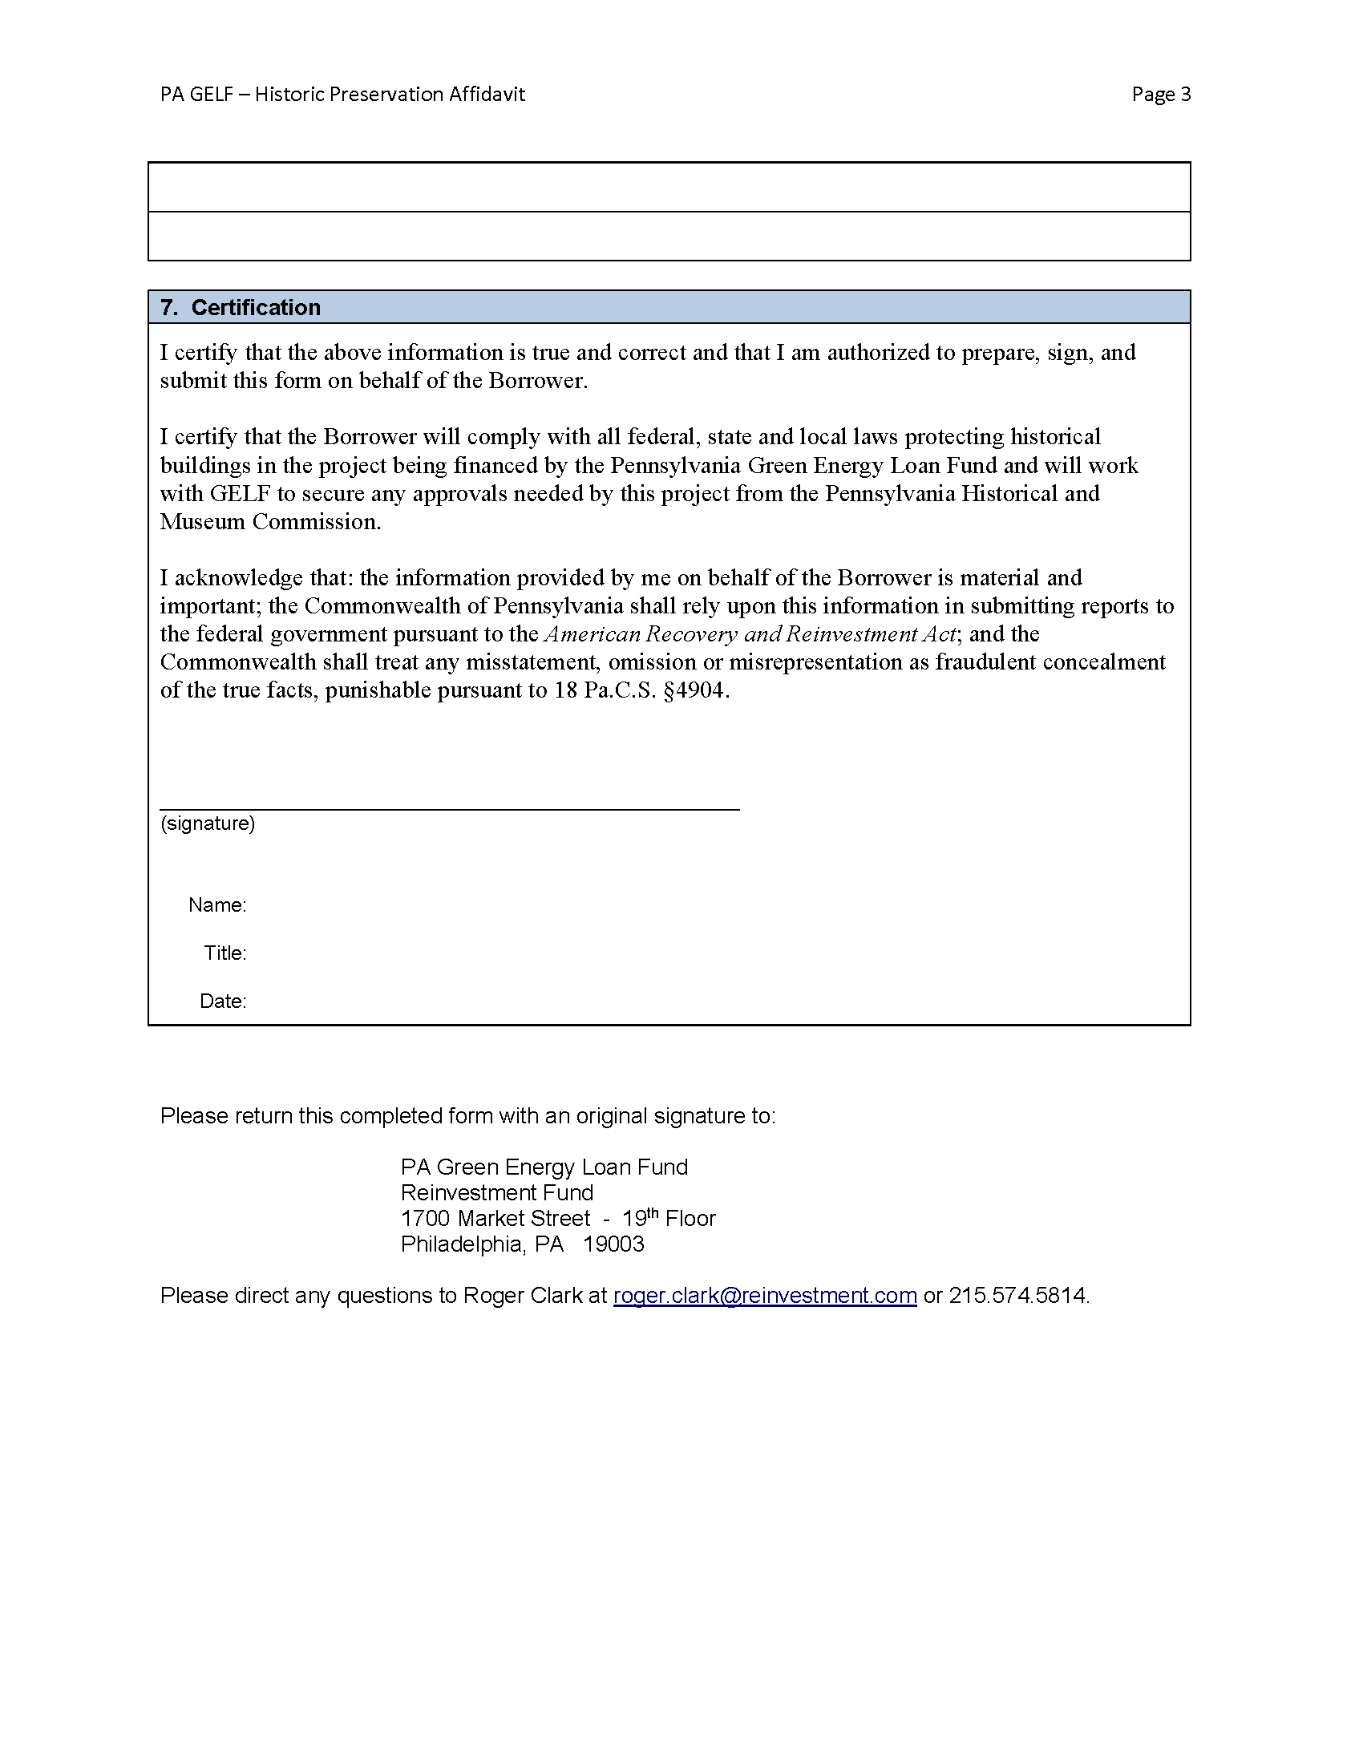

5. Project Waste Management Plan
A. Background
The Pennsylvania Green Energy Loan Fund (“GELF”) must ensure that sound waste management plans are in place for all energy projects financed by GELF. These regulatory requirements flow from the U.S. Department of Energy (“USDOE”) to the Pennsylvania Department of Environmental Protection (“PADEP”) to Reinvestment Fund to all GELF loan recipients. As a condition to receiving a GELF energy loan, all GELF loan recipients must prepare and submit a GELF Waste Management Plan Affidavit that identifies the waste that their project will generate and their plans for handling, recycling and disposing of that waste. This affidavit is described in section 5.B.1 below and a copy of the affidavit is included in Attachment 5 of this GELF Procedures Manual.
B. GELF Loan Recipient Actions
- The GELF Loan Recipient shall complete and submit a GELF Waste Management Plan Affidavit that is provided as Attachment 5 of this Procedures Manual. This affidavit is a condition of loan closing and must be submitted prior to the GELF loan closing date. The copy of GELF Waste Management Plan Affidavit is provided as Attachment 5 for reference only. GELF staff will provide GELF loan applicants with the electronic version of the affidavit, which is a Microsoft Word form that has fields that expand to the needed size for each answer. GELF loan applicants should fill out the Microsoft Word version of the affidavit.
Early discussion with GELF staff about this affidavit and the waste management issues are strongly encouraged. Any questions should be directed to Roger Clark at roger.clark@reinvestment.com or by phone to 215.574.5814.
The completed affidavit with an original signature is to be submitted to:
Roger Clark
PA Green Energy Loan Fund
Reinvestment Fund
1700 Market Street - 19th Floor
Philadelphia, PA 19103.
In addition to the hard copy, an electronic version of the completed affidavit is to be emailed to:
roger.clark@reinvestment.com
- Every GELF Loan Recipient will submit an updated GELF Waste Management Plan Affidavit as necessary to capture any changes to the waste management plan or the status of compliance with waste management provisions.
C. Reinvestment Fund Actions
- Reinvestment Fund will provide a copy of these Project Waste Management Plan procedures to each GELF loan applicant and will respond to any questions that the applicants have.
- Reinvestment Fund will distribute the GELF Waste Management Plan Affidavit to all GELF loan applicants and will work with all GELF Loan Recipients to ensure the affidavit is completed and submitted to Reinvestment Fund prior to loan closing. The affidavits will be available to PADEP staff for inspection.

Attachment 5: GELF Waste Management Plan Affidavit

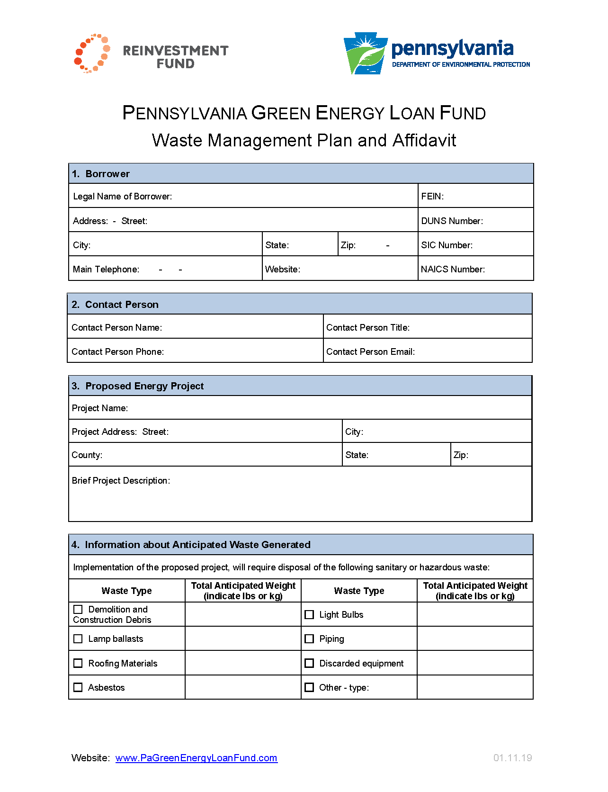
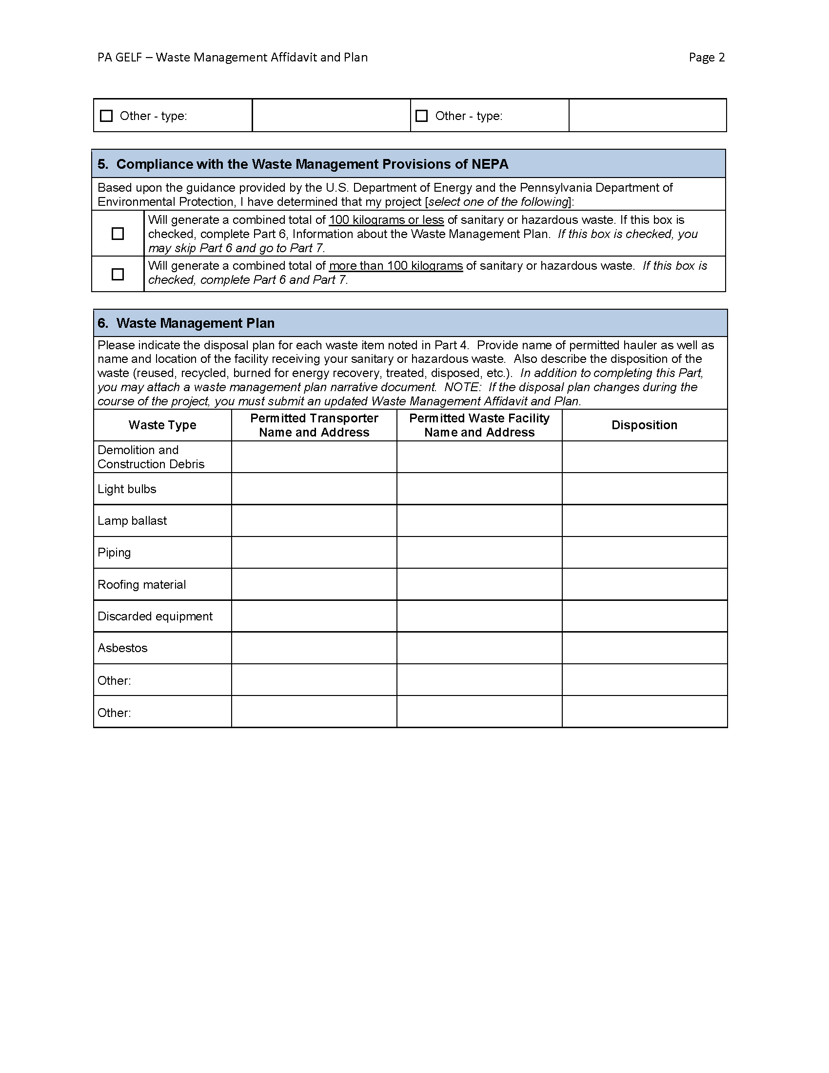

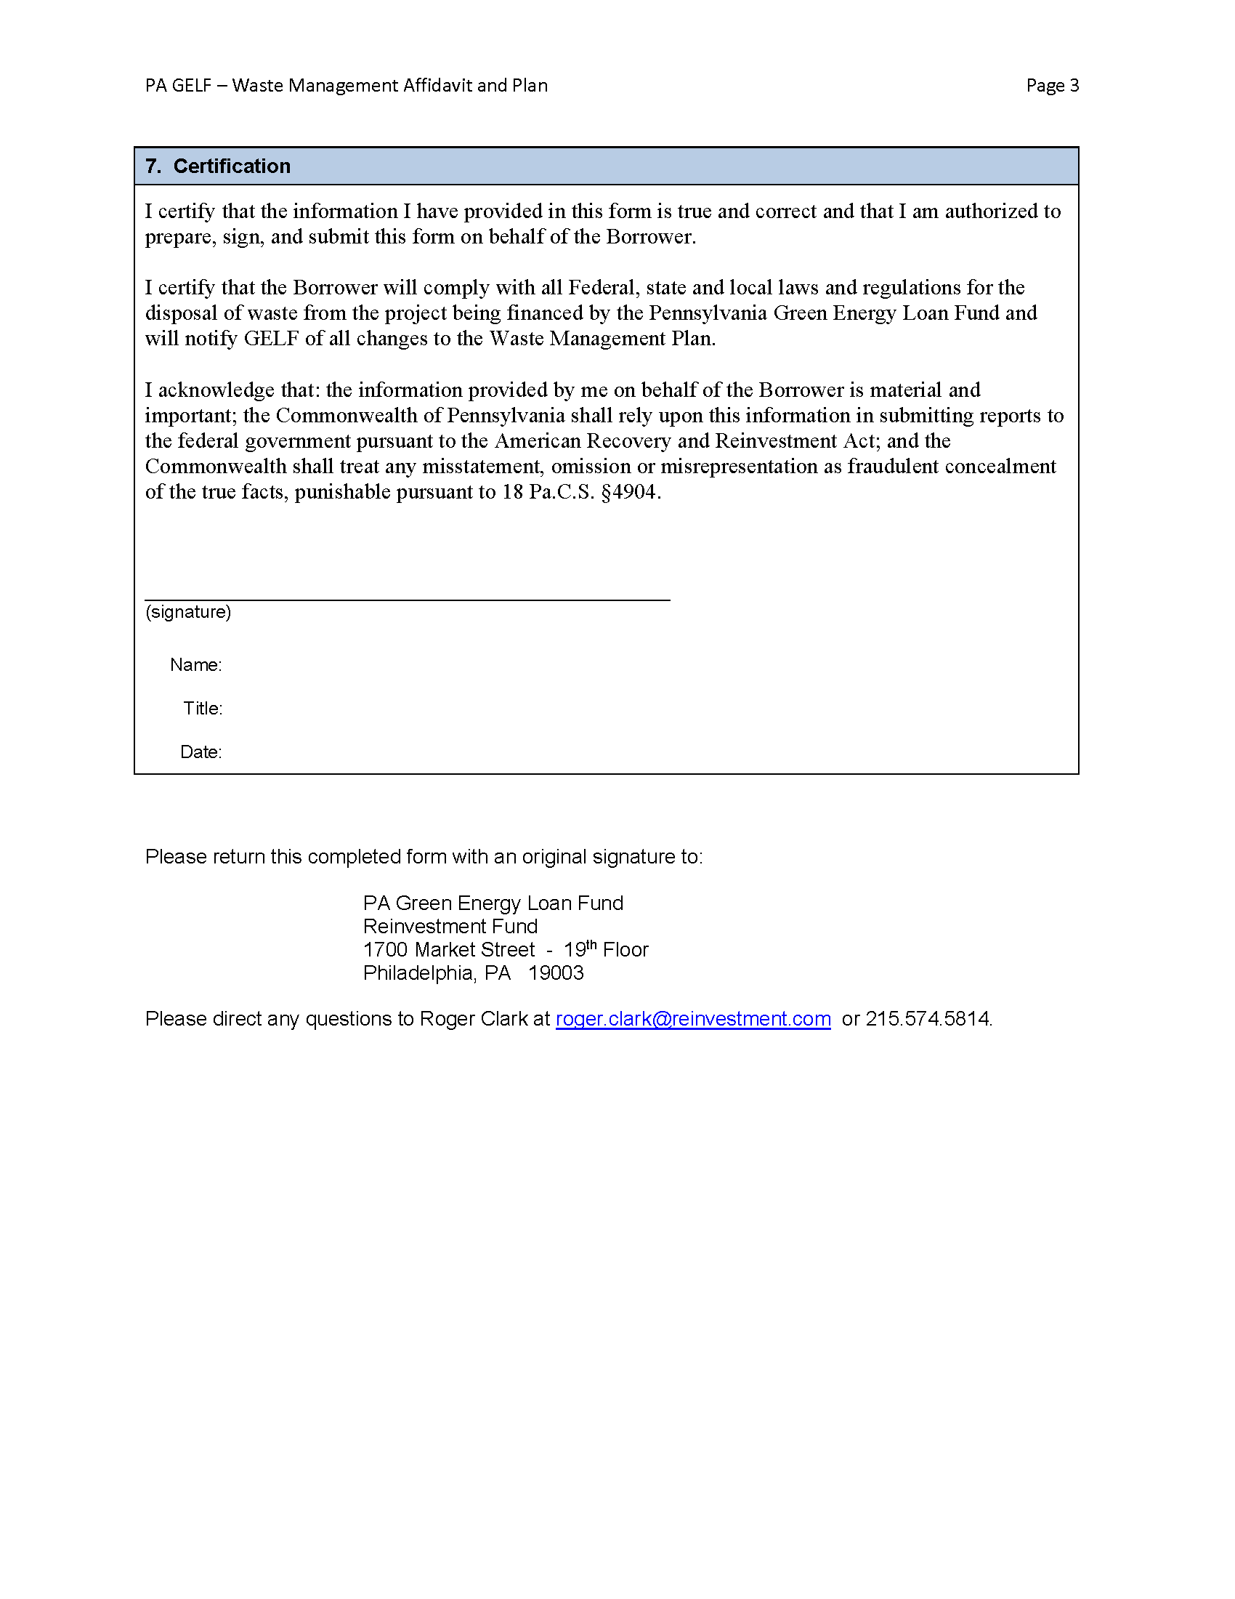

6. Buy American Provisions
A. Background
If a GELF loan recipient is a government entity (the United States; the Commonwealth of Pennsylvania, a county or local government, or a multi-state, regional, or interstate entity which has governmental functions) and the financed project involves a public building, the Buy American provision in the American Recovery and Reinvestment Act of 2009 (§1605 of Title XVI) will apply. The Buy American provision requires that all the iron, steel, and manufactured goods used for the construction, alteration, or repair of a public building or public work must be produced in the United States, subject to three listed exceptions.
Important information about section 1605 of Title XVI of the Recovery Act (the Buy American provision) is available on a dedicated section of the website of DOE’s Office of Energy Efficiency and Renewable Energy (EERE): http://www1.eere.energy.gov/recovery/buy_american_provision.html. This section will be updated regularly with new documents pertaining to the Buy American provision (e.g., Frequently Asked Questions (FAQs), formal guidance, and waivers).
On December 19, 2009, the U.S. Department of Energy issued a guidance document entitled Guidance on the Buy American Provisions as Applied to Energy Efficiency and Renewable Energy Projects Funded by the American Recovery and Reinvestment Act of 2009 and Administered by the Office of Energy Efficiency and Renewable Energy. This Guidance is located at http://apps1.eere.energy.gov/state_energy_program/ pdfs/buy_american_program_guidance.pdf. DOE has issued additional materials regarding the Buy American Provision on its website at http://www2.eere.energy.gov/recovery/ buy_american_provision.html.
USDOE has prepared a useful Desk Guide to the Buy American Act. This document is available at http://www1.eere.energy.gov/recovery/pdfs/buy_american_desk_guide.pdf
B. GELF Loan Recipient Actions
- If the GELF Loan Recipient and the project are subject to the Buy American provisions of ARRA, the GELF Loan Recipient will review all U.S. Department of Energy guidance on Buy American and will comply with the Buy American requirements.
- The GELF Loan Recipient shall complete and submit a GELF Buy American Affidavit that is provided as Attachment 6 of this Procedures Manual. This affidavit is a condition of loan closing and must be submitted prior to the GELF loan closing date. The copy of GELF Buy American Affidavit is provided as Attachment 6 for reference only. GELF staff will provide GELF loan applicants with the electronic version of the affidavit, which is a Microsoft Word form that has fields that expand to the needed size for each answer. GELF loan applicants should fill out the Microsoft Word version of the affidavit.
Early discussion with GELF staff about this affidavit and the Buy American requirements are strongly encouraged. Any questions should be directed to Roger Clark at roger.clark@reinvestment.com or by phone to 215.574.5814.
The completed affidavit with an original signature is to be submitted to:
Roger Clark
PA Green Energy Loan Fund
Reinvestment Fund
1700 Market Street - 19th Floor
Philadelphia, PA 19103.
In addition to the hard copy, an electronic version of the completed affidavit is to be emailed to:
roger.clark@reinvestment.com
- Every GELF Loan Recipient will submit an updated GELF Buy American Affidavit as necessary to capture any changes to the status of compliance with the Buy American provisions.
- If the GELF Loan Recipient intends to request a waiver of the Buy American requirements for any component of its project (see http://www1.eere.energy.gov/recovery/pdfs/ eere_buy_american_nonavailability_template.pdf), it will complete and submit to Reinvestment Fund the initial draft of the waiver request for review and comment.
- The GELF Loan Recipient will comply with the procedures described in the U.S. Department of Energy’s document (or its successor) Guidance on Documenting Compliance with the Recovery Act Buy American Provisions, effective May 24, 2010, at http://www1.eere.energy.gov/recovery/ pdfs/eere_buy_american_documentation_guidance.pdf.
- The GELF Loan Recipient will provide Reinvestment Fund with copies of any and all documents demonstrating compliance with the Buy American provisions.
C. Reinvestment Fund Actions
- Reinvestment Fund will provide a copy of these Buy American procedures to each GELF loan applicant and will respond to any questions that the applicants have.
- Reinvestment Fund will distribute the GELF Buy American Affidavit to all GELF loan applicants and will work with all GELF Loan Recipients to ensure the affidavit is completed and submitted to Reinvestment Fund prior to loan closing. The affidavits will be available to PADEP staff for inspection.
- If the Buy American provisions do not apply, no further action is necessary.
- If the Buy American provisions do apply, Reinvestment Fund will:
  - Direct the GELF Loan Recipient to the Buy American webpage of the U.S. Department of Energy (http://www1.eere.energy.gov/recovery/ buy_american_provision.html).
  - Direct the GELF Loan Recipient to the U.S. Department of Energy’s document (or its successor) Guidance on Documenting Compliance with the Recovery Act Buy American Provisions, effective May 24, 2010, at http://www1.eere.energy.gov/recovery/ pdfs/eere_buy_american_documentation_guidance.pdf.
- If a GELF Loan Recipient is requesting a waiver, Reinvestment Fund will review the GELF Loan Recipient’s first draft of the waiver request form and propose any appropriate changes. Once Reinvestment Fund and the GELF applicant are in agreement with the draft waiver request, Reinvestment Fund will forward the waiver request to the DEP GELF program officer for review and final edits. The DEP GELF program officer will file the waiver request form with DOE for review and approval.
Reinvestment Fund will communicate DOE’s final action on the waiver request to the GELF Loan Recipient.
- Reinvestment Fund will monitor whether it has received from the GELF Loan Recipient the documentation to show compliance with the Buy American provisions. Reinvestment Fund will contact the GELF Loan Recipients who fail submit the Buy American documentation. All documentation of Buy American compliance will be filed in the GELF Loan Recipient’s project file. All Documents will be provided to DEP’s Program Officer for review and approval.

Attachment 6: GELF Buy American Affidavit

